Instructions

Student’s Name
Institutional Affiliation
Course Name and Number
Instructor’s Name
Assignment Due Date

Memo
To:
From:
Date:
Re:

Introduction
Cardiovascular disease has become a public health concern in the recent years. It has been established that cardiovascular disease is the leading cause of mortality and morbidity in developed countries. CVD has become the common problem managed in general clinical practice. Cardiovascular disease prevention is a key objective in primary care. Healthcare providers recommend lifestyle interventions as a more efficient way to combat CVD in addition to clinical care such as medication to lower blood pressure and cholesterol. Therefore, the care of the client is at their hands, and as such there is need to involve them in decision making concerning their cardiovascular disease risk. This has led to development of online patient aids to help them access shared decision making with clinicians. One of the online patient aid is Cardiovascular Risk Tool. This tool is a free online aid which enables clients monitor their CVS status on their own. It is easy to use.
Basic Information
Cardiovascular Risk Tool is a decision making tool where the patient does their own health assessment of the cardiovascular disease. Shared decision-making is important in that there are many ways to reduce risk and weighing up the benefits and harms of different options depending on individual preferences.
Frequently asked questions
- What is Cardiovascular Risk Tool (CVR Tool)?
Cardiovascular Risk Tool is a health assessment tool for people who are living with or at a risk of having a cardiovascular disease.
- What is the goal of CVR Tool?
CVR Tool was developed to aid in the improvement of patient satisfaction concerning the health care services. It was also developed to ensure that health outcomes are worth the desired quality of the patients as they are involved in the decision making process.
- What are the benefits of CVR Tool?
It makes it easier for individuals to interact with clinicians in order to come up with a health decision that is deemed best by both parties. It also improves patient satisfaction with health care services because they feel that for any decision made they are part of it. Shared decision making is also associated with better health outcomes compared to the traditional ways where the clinician made absolute decisions concerning the health of the client.
What you need:
- Internet access
- Your cardiovascular information card – Blood pressure, weight, height, BMI, cholesterol level.

Instructions
- Go to your internet browser. Then input the URL
https://www.healthdecision.org/tool.html#/
It will take you to a home page of the health decision as displayed below:
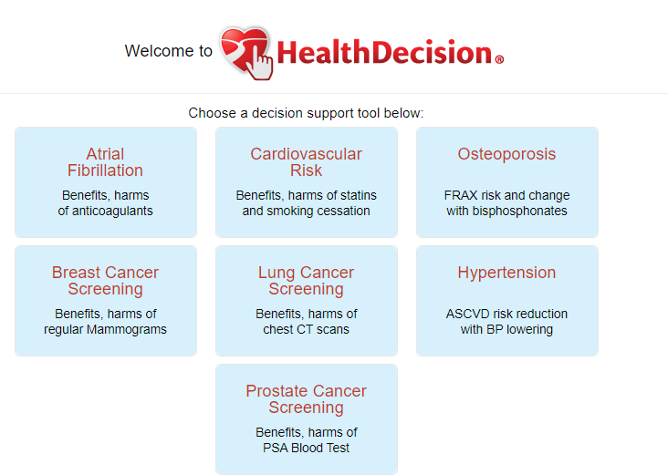
- Select the Cardiovascular Risk tool on the home page as pointed by the arrow.
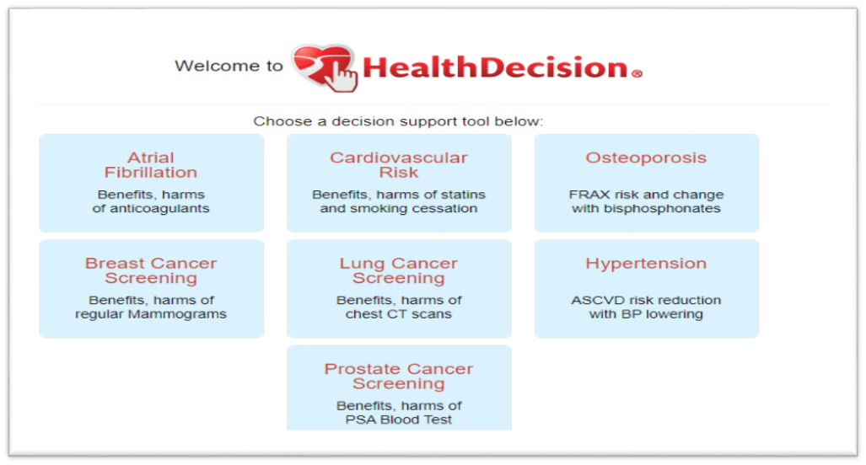
This will take you to the Cardiovascular Risk Tool for Clinicians. It contains:
Instructions, Data, Assessment, Decision, Patient information, Documents and Credits

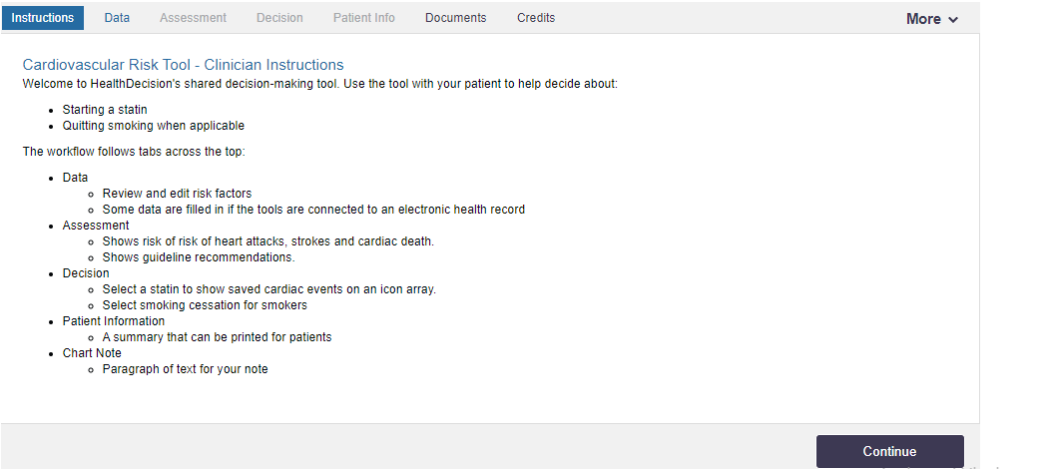
- Click continue at the right bottom corner
It will take you to a page where you are needed to feed your health information data as contained in your health information card.
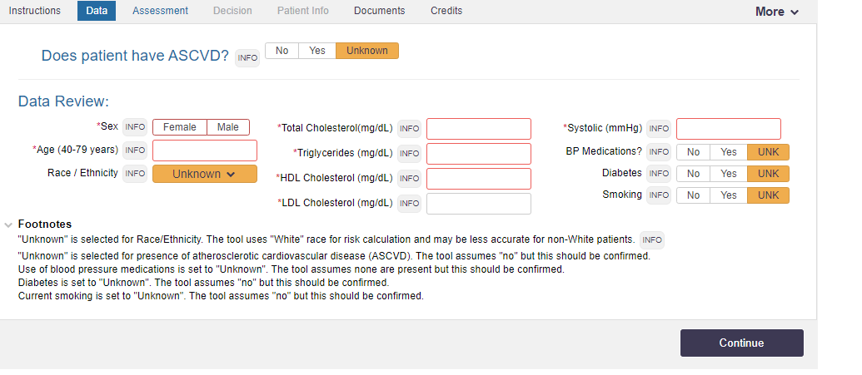

- Remember you must complete this section before proceeding to the next part.
After filing the information, proceed by clicking continue button
It will take you to the assessment part.
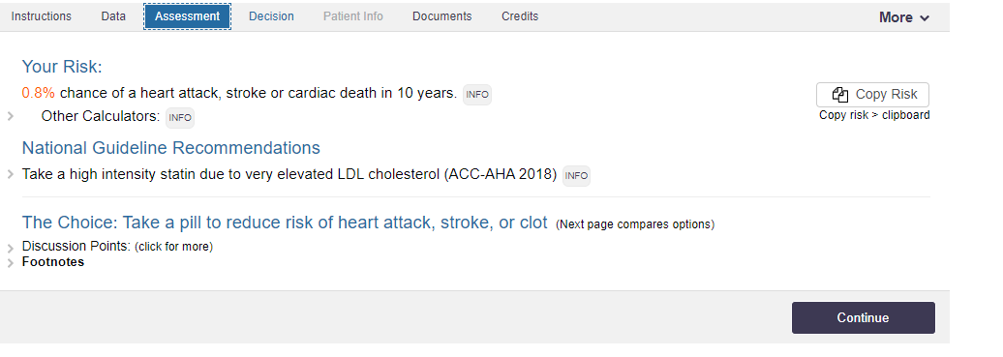
This page gives you an assessment according to the information you gave in the data section.
It will give you a percentage risk of getting heart attack, stroke or cardiovascular death and the time within which you are at risk.
It also contains the national guideline recommendations; this contains the advisory measures you are to take to avoid getting heart attack, stroke or possible cardiovascular death.
The last activity in that page is that it gives you The Choice you have to avert the CVD.

- Click continue.
It will take you a page of Decision, that contains a range of choices from which you will decide an intervention that best suits your risk level.
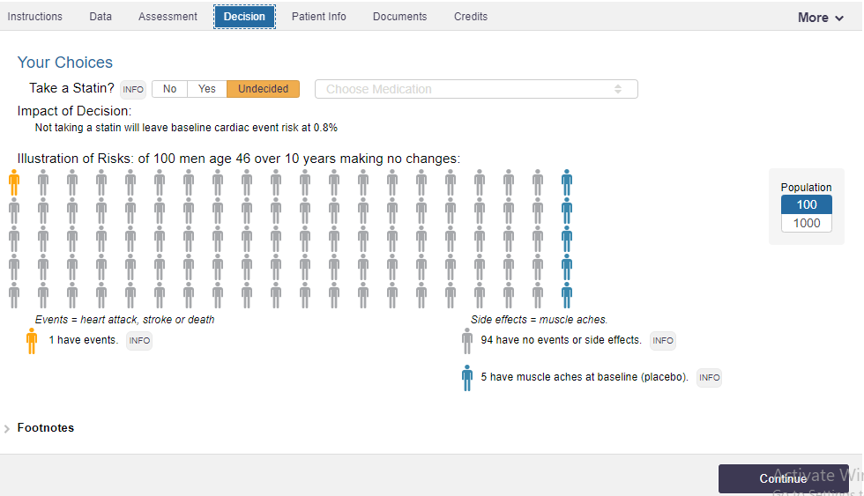

- Click continue
This will take you the patient information page
Here, your information is described in summary
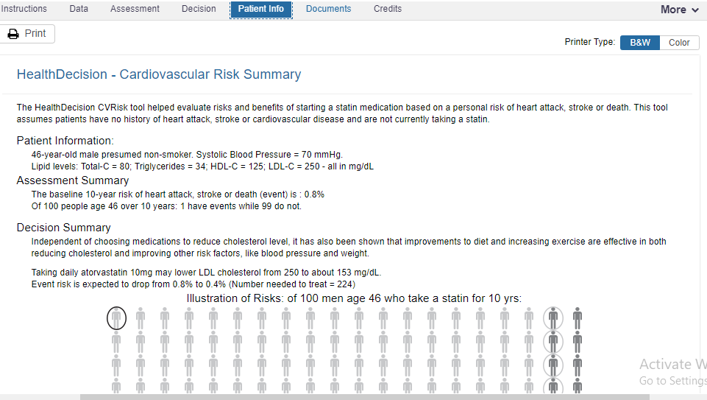

- Click continue.

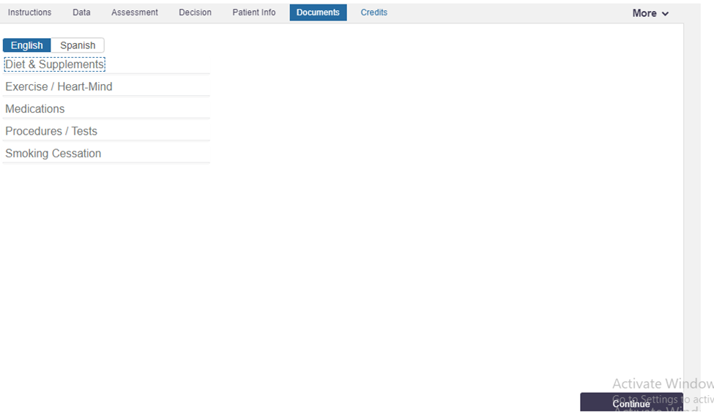

This part contains parts where you will be required to choose your language. It also contains
Priority diet and supplements, heart-mind exercise, medications, procedures/tests, and the final decision, for example cessation of smoking.

- The final part contains credit
This includes the credit for the developers of the tool, research done during its development, source of funds to the development of the tool, conflict of interest during the research for the development of the tool, and updates that might be useful for the shared decision making process about the clients’ cardiovascular status.
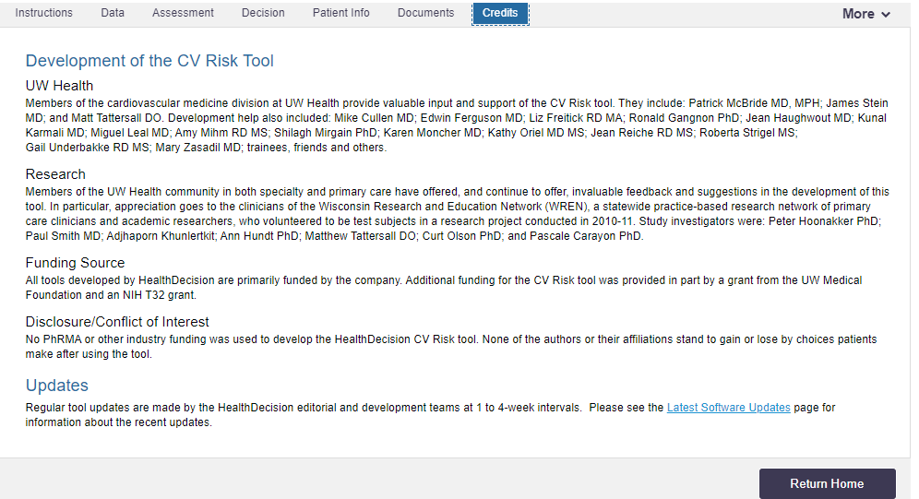

Remember:
- The tool cannot allow you to go to assessment until you fill the required information in the data section.
- It will not also go to the patient information page without you choosing on a decision on the decision page.
- If you click the button more at the top right corner, it will bring a down menu that contains all the components of the home page, that is, tools concerning different conditions such as Atrial fibrillation, lung cancer and breast cancer screening tools.

Hello friend. Please remember to delete this part before submission
Thank you for working with me I must admit that I am really honored to do so. However, please take a look at the uploaded file and see if it meets your expectations. If so, kindly remember to release the funds on time (including a bonus since the work was so complex and long) and leave a 10-star rating. I will be very glad. Again, you can find me on this email (davykikuvi774@gmail.com) in case you have more work in the future. I will be at your service. Thank you in advance.

